**Review on Mechanical Issues and Driver Solutions of Industrial PMAC Servo Systems: Parameter Estimation and Auto-tuning Concepts**

**ABSTRACT**

**As a result of the advanced industrial technology, industrial servo drive systems need advanced skills for managing the system and motion. Industrial servo systems have challenging mechanical characteristic for sensitive control and accurate stability of driver systems. These mechanical issues occur with respect to drive train of servo systems such as mechanical assembly, motion elements, motion types and loads. In this context, on the driver and control side, there are several approach and solution methods for mentioned mechanical issues. In this paper, problematic issues and offered solutions in the current literature for servo drive systems are defined and systematized.**

**Keywords: Servo Drive Mechanics, Mechanical Servo Issues, Filtering in Servo, Servo Control**

**INTRODUCTION**

**A well tuned servo system is robust and has the fastest possible response with (negligible or) no overshoot and steady state error. But, a well tuned servo system can lose its accurate response with disturbances that come from the mechanical dynamics of operated drive train. Drive train of a servo system contains controller-driver, motor and load. Controller-driver can be defined as white box, motor can be defined as grey box and load can be defined as black box. In this manner, tuning of the whole system can be done by controller-driver via motor with reflection from load to motor shaft.**

**MECHANICAL ISSUES**

**Definitions (with figures), Sourced what**

**Model of 2 mass system**

**Reflection to motor and driver side**

**Characterized of issue – peak and width definition of disturbance 1 periodic 2 non periodic**

**Electrical Parameter (PMSM)**

|  |
| --- |
| **Electrical Parameters:** |
| $r_{s}$: Series resistance |
| $L_{d}$: d-axis inductance |
| $L_{q}$: q-axis inductance |
| $K_{e}$: Back EMF constant |
| $λ_{m}$: Rotor PM flux linkage |

**Mechanical Parameter**

|  |
| --- |
| **Mechanical Parameters:** |
| $T_{e}$: Electromechanical torque |
| $T_{L}$: Disturbance load torque |
| $K_{t}$: Torque constant |
| $J$: Rotor and load inertia |
| $B$: Viscous friction coeff. |

**Modelling (mechanical issue disturbance olarak modellenebilir) (critical variables)**

|  |
| --- |
| **Variables:** |
| $P$: rotor pole number |
| $w_{r}$: rotor electrical speed |
| $w_{m}$: rotor mechanical speed |
| $s$: Laplace operator |
| $v_{do},v_{qo}$: Back EMF+Cross coupling |

**DETECTION METHODS**

**How to find disturbance time duration and peak value ? (disturbance freq detection system)**

**-Adaptive approach : Adaptive notch filter ANF Regalia’s algorithm, MRAS**

**-Prior knowledge required: Disturbance observer, Inertial model control**

**-FFT**

**-Kalman Filter (EKF)**

**++freq, amplitude, damping coeff**

**--Require appropriate model, computational requirement (real time implement difficult)**

**-Dissipative control + fitering techniques**

**FILTERING METHODS**

**Notch filter**

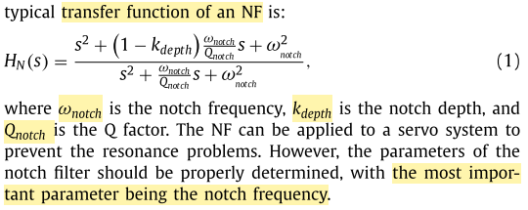

**Biquad Filter**

**Low pass in which conditions**

**Band pass in which conditions**

**SYSTEM MANAGEMENT**

**Detection algoritmaları nasıl çalışıyor, hangi donanımda hangi yazılım koşuyor, Implementasyona uygun methodlar, ne kadar İşlem gücü gerekli?**

**DSP + FPGA**

**DSP: Speed loop, position loop, Robust Adaptive Notch Filter**

**FPGA: Current control loop, FFT, EKF**

**CONCLUSION**